**What is SCRUM?**

Scrum is an agile framework within people can address complex problems, and they deliver the products with the highest possible value in a productive and creative way. It is

* Lightweight
* Simple to Understand
* Difficult to Master

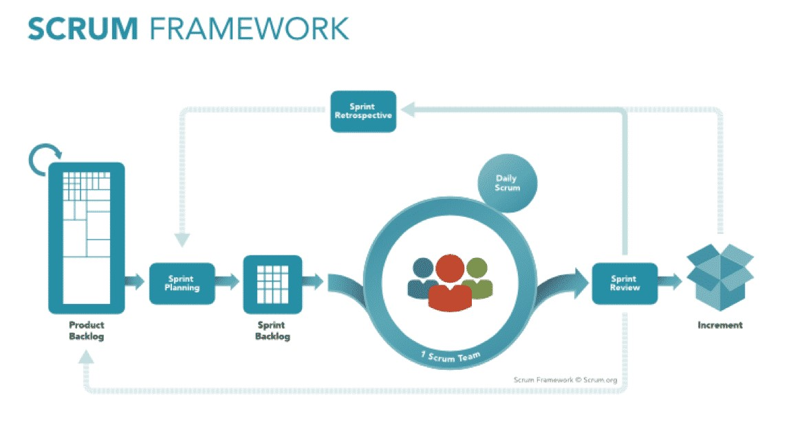

The Scrum Framework comprises of **Scrum Team**, **Daily Scrum**, **Sprint**, **Product**

**Backlog**, **Sprint Backlog**, **Sprint Planning Meeting**, **Sprint Review Meeting**, **Sprint Retrospective Meeting**, **Refinement Meeting.** Now, let’s understand what they are.

**The Scrum Team**

Scrum Team comprises of

* Scrum Master (SM)
* Product Owner (PO)
* Development Team (Cross-functional professionals)

**Scrum Master**

* Encourages face to face communication, the teams’ self-organization, and accountability.
* Solves problems for the team, not waiting for who broke it or who should fix it.
* Ensures the Scrum Team is functional and productive.
* Enacts Scrum values, rules, and practices throughout the organization.
* Provides guidance and support for the Scrum Team.
* Gives regular feedback to the team, and help them to catalyze change.

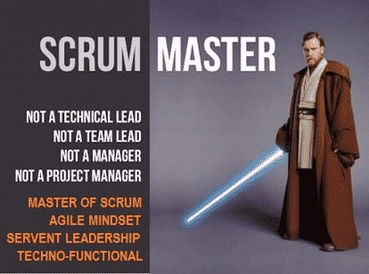

**Product Owner**

* Provides vision for the team, and clearly communicates this to the rest of the team.
* Optimizes and increases the value of the product.
* Creates and maintains the Product Backlog.
* Sets the acceptance criteria for each user story.
* Chooses what and when to release.
* Represents stakeholders and customers to the Development Team.

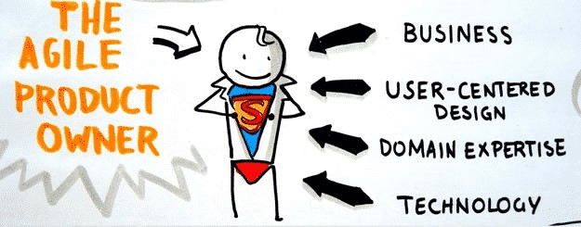

**Development Team**

* Operates series of Sprints.
* Self-organize itself and its work.
* Creates the product increment.
* Works with the PO and optimizes the value.
* Typically, 6 (+3 || -3) members.
* Development team should be cross-functional (backend developer, frontend developer, architect, tester, mobile developer etc.)
* Completes development, test and the other technical tasks to achieve sprint goal.
* Attends all the meetings and ceremonies.
* Communicates the status of the work on a daily basis.

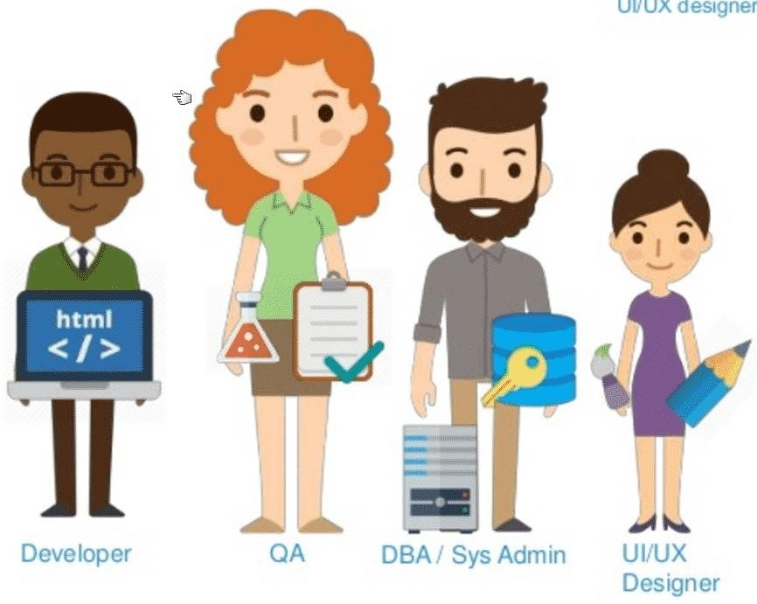

**Artifacts**

**Product Backlog**

* Prioritized list of features that the product owner wants to be delivered.
* Changeable and being evaluated.
* Potential features of the product.
* It should be public and easily available.
* PO should maintain the Product Backlog. This is his/her responsibility.
* A product backlog item is a unit of a deliverable work, contains clear acceptance criteria, comprises of or references to the other artifacts such as mock-ups, models, specifications. It must be sized appropriately.

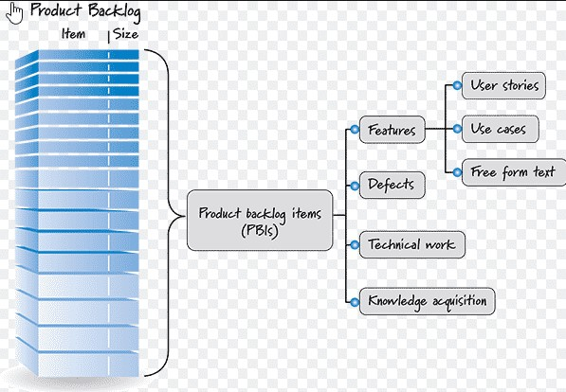

**Sprint Backlog**

* List of tasks identified and prioritized by the Scrum Team to be completed during the Sprint.
* In Sprint Planning Meeting, the team selects some Product Backlog Items (PBIs) to form the Sprint Backlog.
* Teams mostly use Scrum Board to represent Sprint Backlog Status such as **TODO** – **IN PROGRESS** – **DONE** or **OPEN** – **IN**

**DEVELOPMENT** – **IN TEST** – **IN UAT** – **DONE** etc.

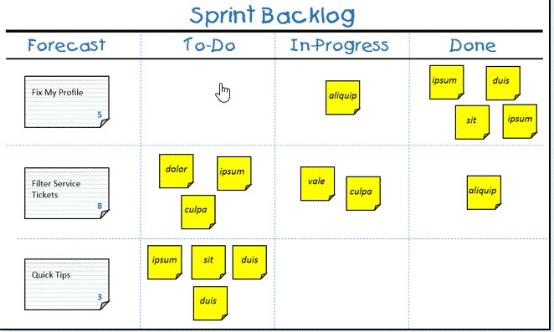

**Increment**

* The usable and working software created in the Sprint.
* Potentially shippable.
* HAS to be DONE!

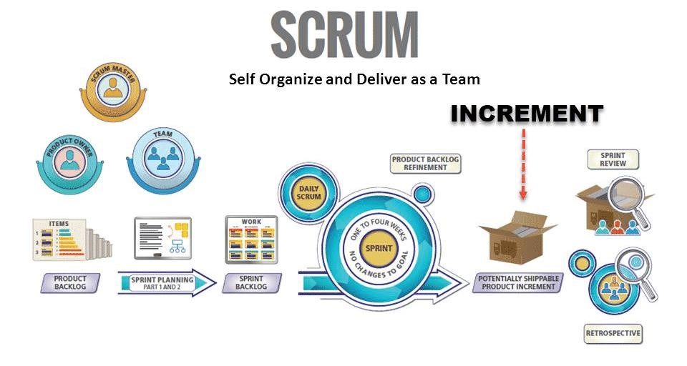

**Scrum Events**

**Sprint Planning**

Sprint planning is a meeting that the development team decides what will be done and how it will be done for the sprint. It is a collaborative effort involving Scrum Master, who facilitates the meeting and the Product Owner describes the details of the PBIs and their acceptance criteria, and the whole team defines the work and effort that fulfills their sprint commitment.

**Inputs**

* PBIs
* Latest Increment
* Development Team Capacity
* Past Performance of the Development Team (Team Velocity Chart) **Outputs**
* The Sprint Goal or Goals
* Sprint Backlog

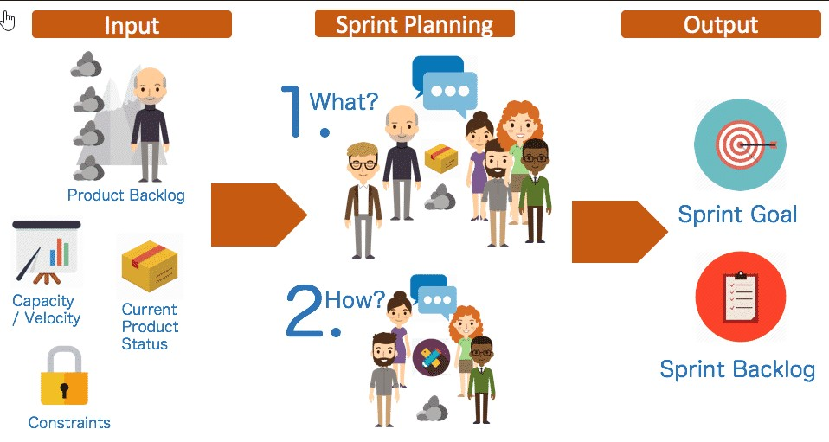

**Daily Scrum** • It is a daily meeting of Development Team.

* Meetings generally established at the same place and the same time in front of the Scrum Board each day in the morning.
* The team assesses progress for the sprint, create a plan for next 24 hours, synchronize the activities, define impediments, and set actions.
* It should finish in 15-minute time-box.

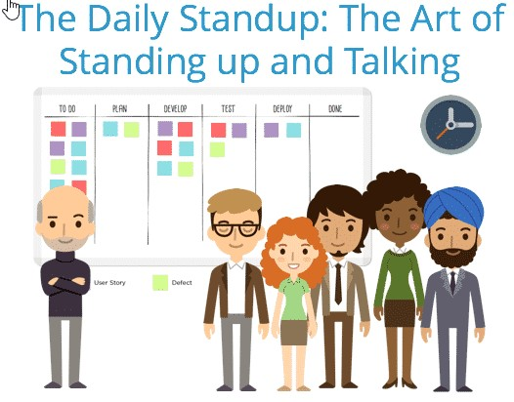

**Sprint Review**

* Scrum Team presents and demonstrates the Product Increment.
* Whole Scrum Team and related stakeholders participate the meeting.
* Scrum Team gets feedbacks from the Stakeholders.
* Feedbacks noted and they will use as guidance for next increment

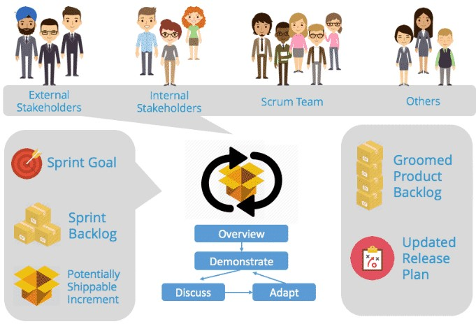

**Sprint Retrospective**

* Inspect and adapt is one of the most critical things in Agile Scrum and this meeting is in inspect and adapt opportunity for the Scrum Team.
* They inspect how the sprint has been passed.
* They decide what and how they want to adapt the process for improvement.
* They set the actions for next iteration.

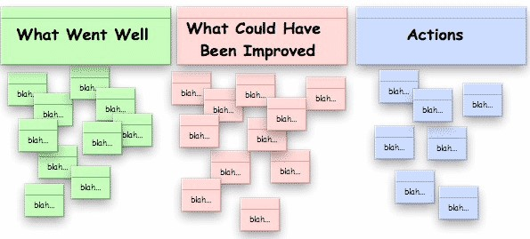

**Refinement Meetings**

Five to ten percent of each Sprint must be dedicated to **Product Backlog Refinement (PBR) Meetings**. This meeting comprises:

* In-depth requirements analysis.
* Breakdown user stories into smaller ones.
* Estimate new PBIs.
* Re-estimate the existing PBIs.

PBR is not for current sprint, it is for the PBIs in next sprints. It is better to do refinement for the next two sprints. Thus, sprint planning meetings will be much more effective and fast because PO and SM start the planning with a well-defined and clear list of user stories. If it is not done, sprint planning will be completely messed. Scrum Team asks too many questions and there will be too much confusion.

I also want to share with you **important values of the scrum** as shown below: **Courage**, **Focus**, **Commitment**, **Respect**, **Openness**

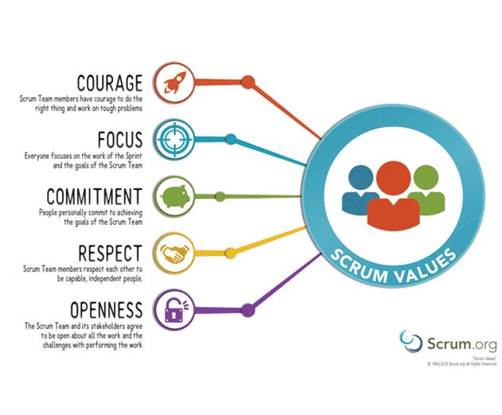 and [**10 Principles of an Agile Tester**](http://blog.belatrixsf.com/10-must-have-principles-for-agile-testers/) is listed below:

* Provide continuous feedback.
* Deliver value to the customer.
* Enable face to face communication.
* Have courage.
* Keep it simple.
* Practice continuous improvement.
* Respond to change.
* Self-organize.
* Focus on people.
* Enjoy!